WEEK 3

**Week3**

**Video-1) Introduction**

Building AI in you company and its key points discussed.

**Video-2) Case study: Smart Speaker**

When a user is trying to use a smart speaker and suppose says “Hey, device tell me a joke!”  
Then the voice is interpreted into following segments:

Similarly Frequent other commands can be interpreted like this fashion.

Similarly these is another sample case to study for self-driving cars.

**Video-3) Case study: Self-driving Car**

**Video-4) Example roles of an AI Team**

Understand various roles and their working area in their domain.

Various Roles like Software Engineer, Data Scientist, Data Engineer, ML Researcher, ML Engineer, AI project Manager.4

Note: Andrew ng course instructor advice is even if nobody is with you in team and you are alone, imply what you know and start building AI project. Don’t wait. God has planned something for you.

**Video-5) AI transformation Playbook [part-1]**

The course instructor is explain about certain steps:

1). Execute pilot projects to gain momentum

- Project should be more successful rather than valuable

2). Build an AI team

- build a centralize AI team and matrix wise distribute the work under corporate positions like CTO (Chief technical officer,

CIO (Chief Investigation Officer),

CDO (Chief Data Officer) or

CAIO (Chief AI Officer).

3). Provide broad AI training

Few AT Team roles and What they should learn

**Video-6) AI transformation Playbook [part-2]**

4). Develop an AI strategy

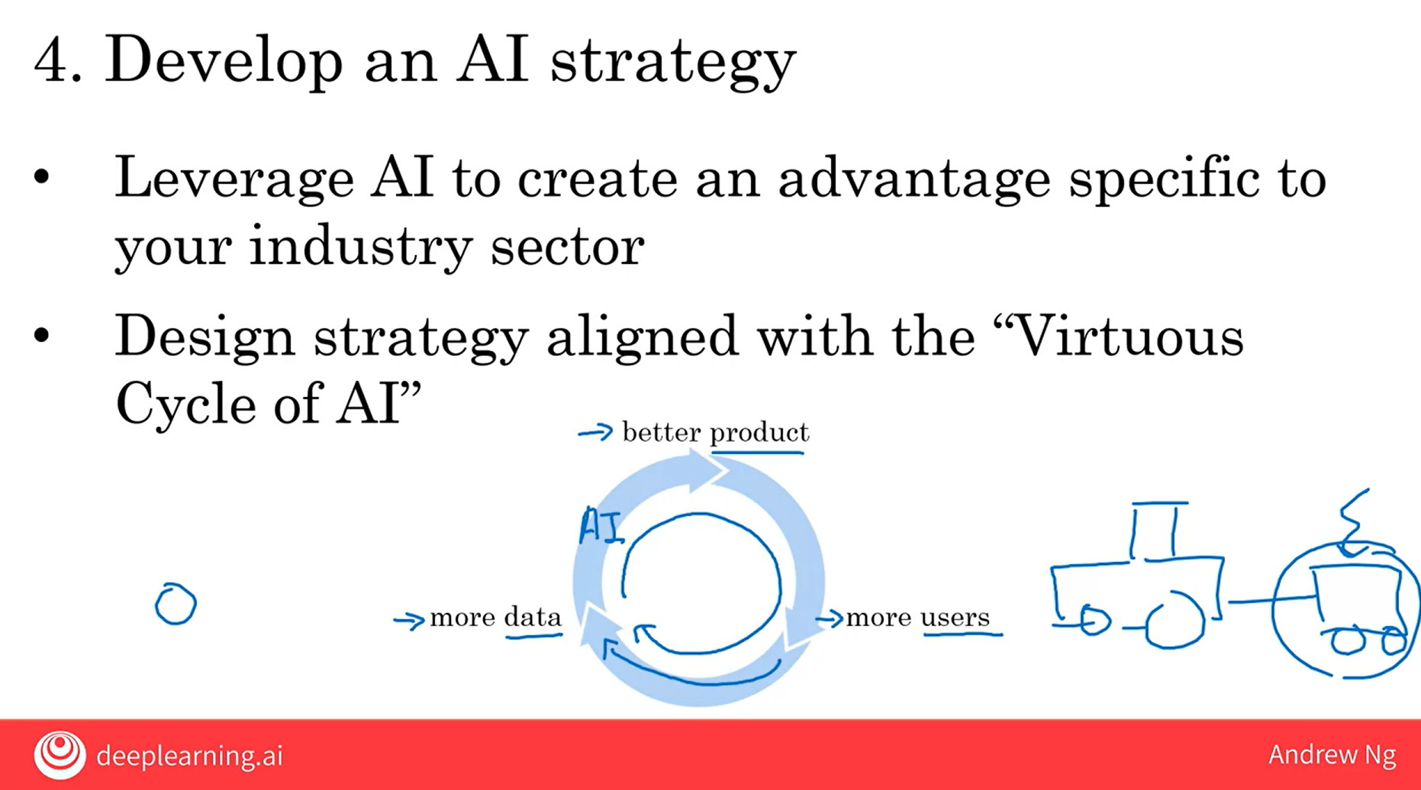

5). Develop internal and external communications

**Video-7) Pitfalls in AI**

Try to avoid the given pitfalls

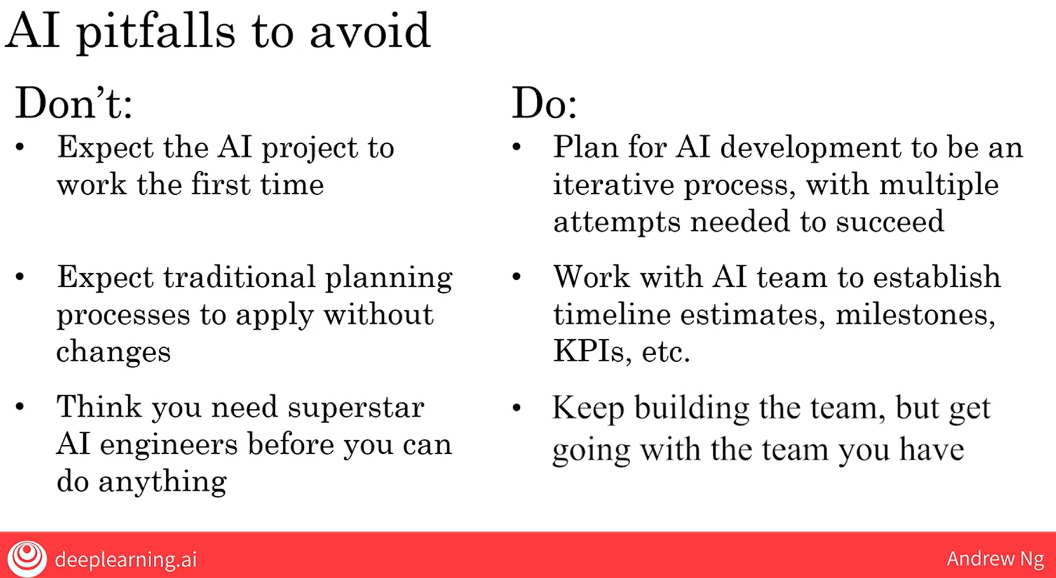

**Video-8) Taking your first step in AI**

Basic understanding of How to initiate project even with small AI team or none.

**Video-9) Survey of major AI application areas**

Understood the concept of Natural Language Processing (NLP) its application in speech and recognition difference between object detection and Image Segmentation AND we found that in Object detection for each object boxes are labelled whereas in Image Segmentation the object is decoded to highlight the full area of object with colour segmenting areas.

**Video-10) Survey of major AI techniques**

Today the value created by Unsupervised learning is much smaller than supervised learning but scientist believe that unsupervised learning will serve as better option in comparison to supervised learning due to the fact that supervised learning needs lots of more data to learn by itself.